

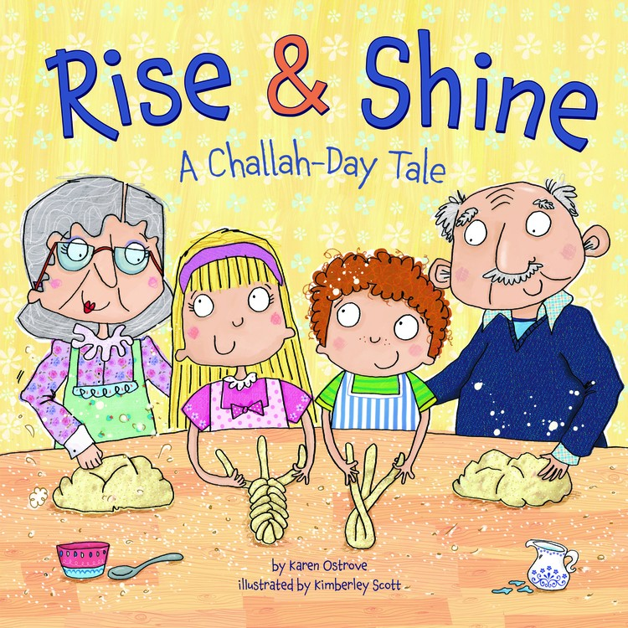**In the Field**

**Rise & Shine, A Challah-Day Tale (3’s)**

**By Karen Ostrove**

**Illustrated by Kimberly Scott**

**Published by Kar-Ben Publishing**

**Who's in the Block Corner?**

|  |
| --- |
|  |

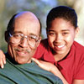Teachers in Pinellas and Pasco counties in Florida, inspired by Rise and Shine, want to encourage children to think about senior members of their families in all aspects of their play. The teachers asked for photographs of grandparents, great aunts, and uncles, and older family friends. The teachers laminated the photos and taped them to blocks to populate the building block structures.

**Facial Expressions**

Rise and Shine features a delightfully crotchety senior named "Grumpy Old Ned." As you go through the book, you may notice that Grumpy Old Ned becomes less and less grumpy. This inspired Tamara Bekker from [Hochberg Prep ECA](http://cp.mcafee.com/d/FZsScy1J5Asy-eLtBYTsSCyPtxMQsTuvdFEIT76zB4syMrjhpKMUqerLe6QQmkmjhOqekNPNI-ld5jVjlS0a9Anu00COp5Tw09JcsWeLp5_HYOyU-COZRXBQjhOYeVxBYQsFEIsJt6OaqJXKsG7DR8OJMddFL6ShNKVKVI075e_hEVMdOse004LeLt6gKbEcK0OiRxPrEbxcwhld790MO5v5M74Bg860m1g2y8Q2gm6f0X8i0wCjc1mc063dwO6OG1gt81QjOEIqehkrcyEp0xW4k0Y1w-NcIa28MmobxkbIH3jdtc1A4C07s0Eawjc5y870U4cxUsmy1NRn_jvv60O8ur-BAkkmhPPbXzbPWoGyztd5BcQsI9L6zCUGMyYqehMH5eUaB3HlxiuMDqI9XqvbCT1PZS3obBjPh1I43h0c4VgYQgCXCSlOZ) in Miami to discuss facial expressions with her students. The children studied their own faces and each other's faces. The children then attempted symmetry drawing - each student got a photo of 1/2 of a face which they had to complete.

**Rise and Shine From Every Angle**

Ania Diaz from the [Hebrew Academy](http://cp.mcafee.com/d/FZsS91MQrhp78LzHTpvdTdFEITosd7dTDPqqbdNNEVh78I6QQmrIe6zCXPxJd5B5AQsCzBcsYrfBjhk-kRtw2yp5Tw09IChtU02rj7ezHShvW_cEKfFILtuVt4QsL3Kopvd7aqb7bnhIyCHuXDaxVZicHs3jqpEVdIzztPtPo0eat-zhPwrAUs009utuWcxsngps1ABHccAUxc23cRgM1cQ_5M70l6BwK4M5jh0EcL2XBnt6614JsayXJzNN1VYiGO2Q5wYb30960M9l0t45yEp0ok2r0SJ1Yf2ocr2gse4yQH283wabz8JZ1sb1B7POE52XPVofm0sUUTZb8EEIzDCnT6nDQNl56WqbapEVojud7dNlx5UQszxmatMla7mH2AZxeRojSQ-ndK3DXI6MnaDCy3o86y0o9OxVExdTdZX8tn2qiK2G5) in Miami makes an activity web with her students. Look at all of the possibilities! She also created a Venn diagram with her class to highlight the similarities and  differences between Rise and Shine and It's Challah Time.

**Yiddish Culture Day with Families**

Miami educators challenged themselves to think about bringing Rise and Shine to life with drama and music. When they re-read their list, they realized what a perfect day of Yiddish culture and fun it would make. Play Klezmer music (or hire a band) and invite seniors to dance with children. Stock up on aprons and cook some kugel (noodle pudding) together. Who know some Yiddish poems or songs to teach everyone?



**Rise and Shine at Camp**

Wake up and smell the challah! The **Schiff Preschool of Temple Emanu-El** in Atlanta, Georgia answered the question, “Where will the future challah bakers of America come from?” Campers last week became “Mini Schiff Chefs” after reading *Rise and Shine, A Challah Day Tale*. Families contributed challah recipes from grandparents and friends, and volunteers came to help with kneading and baking. The Atlanta community has lots of kosher bakeries, so participants in their weekly Shabbat Sing got to sample challah from all of them. Now that is something to sing about!