

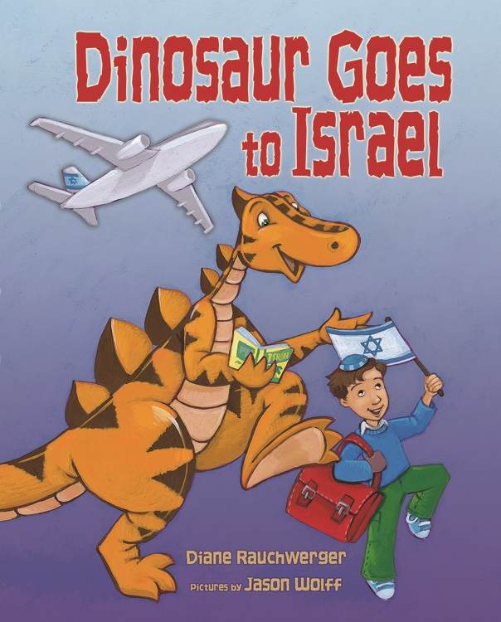**In the Field**

**Dinosaur Goes to Israel (3’s)**

**By Diane Rauchwerger**

**Illustrated by Jason Wolff**

**Published by Kar-Ben Publishing**

**Israel Centers**

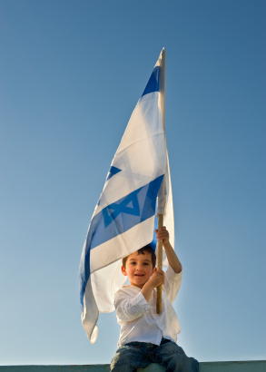

"[*Dinosaur Goes to Israel*](http://r20.rs6.net/tn.jsp?e=001a_BWuuLUYkBW6v8dc4EWpFlzTJ-s99ktW6LIhL4kMHHAfvV8Nj3KXM4HHuJd_KkBlqzEL1Dr5K4GWPPs11MK6-cSnddDsllnLzbd3zS26j-0BZbqFGBknnHwvmDqTw4Bs9_h_F-VZ5b7pVFxK12ZdpRy3nuAsPms) lends itself perfectly to a centers and play-based curriculum," says Lauren Young of [Kol Emet Preschool](http://r20.rs6.net/tn.jsp?e=001a_BWuuLUYkBuxuLiHjgtw-Yn8So2nUZDAa0CfZjjDMwAS-2w2mFO58KCnilDCiUvIelhm5-g2Bu4TVT7JQ956AuOKBBzTKfhzZpDlb6a8MoV7_AwxZ_taYlSY2hID51v) in Philadelphia. She plans to add items such as olive wood, embroidered cloth and spices to her dramatic play area in order to encourage the creation of a shuk, an Israeli marketplace. They might do a unit on money if the children love the shuk/store play.  Lauren will also provide the children with recipes, further enhancing their math skills -- and their culinary palate.

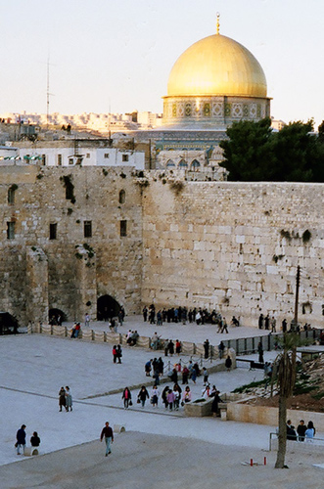**Great Minds Think Alike**

Janet Clement Rodriguez ECE, Director at the [JCC Suncoast Children's Center](http://r20.rs6.net/tn.jsp?e=001a_BWuuLUYkDWxCS5ROzlP00ByrOIFApQ7D3lCWpsEud8zO71awYexAE6p6w4bKqI5vZj-Pym8mLOG5F9cWlQCULINZ0nhDpsujysLeM1NM7oy-gxa1hbrQ==) in Pinellas County as well as Binnie Edelson, Director of [Congregation B'nai Torah](http://r20.rs6.net/tn.jsp?e=001a_BWuuLUYkAkubZekcIr0XnmcjGW1Z5sgqTheNiYp7dBXw11zwZL-pGBNq1er2uXRZzHQiGa4ynw8ntYFe4G3FJ3wqwqZU5pjkbMjnIuKAcuUCKBICUWNA==) in Atlanta are planning "Trip to Israel" events inspired by our PJ Goes to School books. Each classroom will be a different site with appropriate activities. Parents will be the tour guides -- what a great way to involve families! (You can enlist children's help as tour guides, too.) Suggestions for each station include a museum display in Tel Aviv, creating mosaics in Tzfat, sand art in the desert, making orange juice at a kibbutz, planting trees in the Galilee, tasting Israeli foods at an outdoor café, and of course putting messages in the Kotel in Jerusalem.

**How Do We Get There?**

Many teachers love to take children on an "airplane" ride to Israel, but the 3's teachers of [Kol Emet Preschool](http://r20.rs6.net/tn.jsp?e=001a_BWuuLUYkBuxuLiHjgtw-Yn8So2nUZDAa0CfZjjDMwAS-2w2mFO58KCnilDCiUvIelhm5-g2Bu4TVT7JQ956AuOKBBzTKfhzZpDlb6a8MoV7_AwxZ_taYlSY2hID51v) in Philadelphia point out other modes of transportation in [*Dinosaur Goes to Israel*](http://r20.rs6.net/tn.jsp?e=001a_BWuuLUYkBW6v8dc4EWpFlzTJ-s99ktW6LIhL4kMHHAfvV8Nj3KXM4HHuJd_KkBlqzEL1Dr5K4GWPPs11MK6-cSnddDsllnLzbd3zS26j-0BZbqFGBknnHwvmDqTw4Bs9_h_F-VZ5b7pVFxK12ZdpRy3nuAsPms). There are cable cars, taxi-cabs, and camels for a start. This could be the beginning of a transportation exploration.

|  |
| --- |
|  |

