

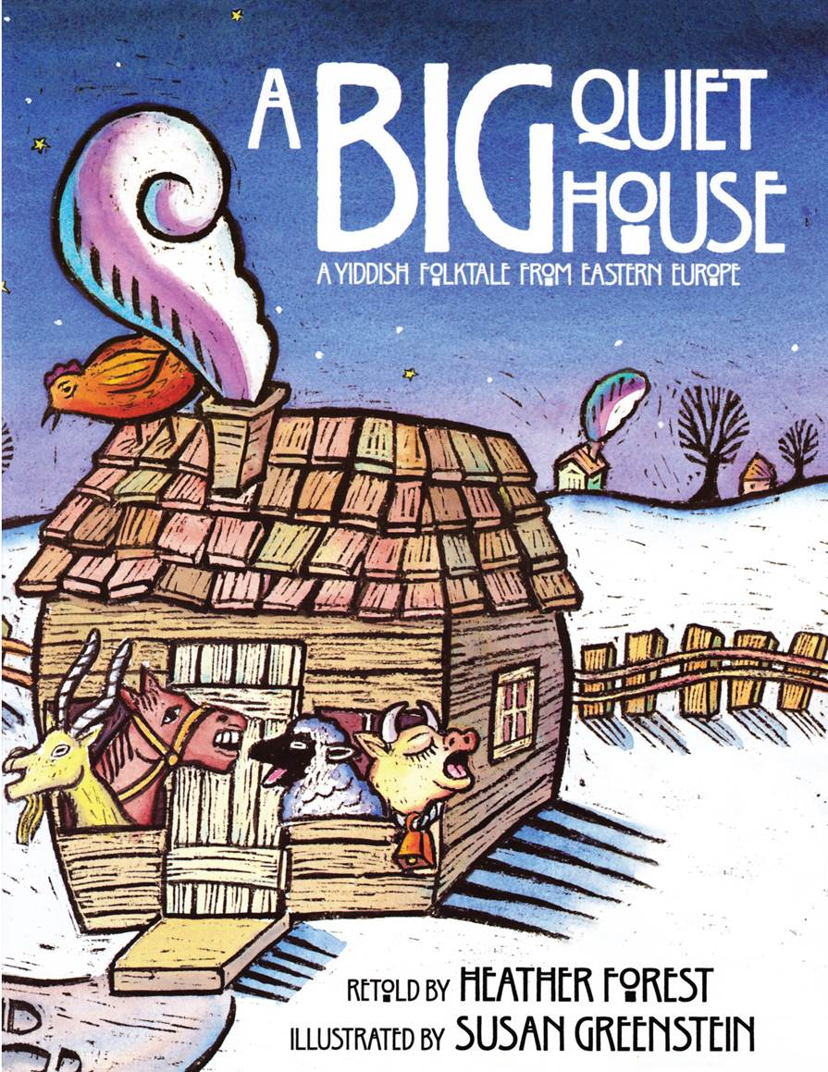**In the Field**

**A Big Quiet House (4’s)**

**By Heather Forest**

**Illustrated by Susan Greenstein**

**Published by August House**

**Wise Advisor of the Day**

The man in [*A Big Quiet House*](http://r20.rs6.net/tn.jsp?e=001NlDyMOUSh4Y7CbNPlETtxPUQ1NnVZKKwvM07x3Ra89WW9wri_hHtVy6UERn800V4j7Z0iUC_25Et8KNTpDkTczLkkrIMFUuk6tHeNYGosMKen-0GTrOc4Z_gqSl1d1YYFPmqsX7FMa69kpKD9uuGSdtGRNDFR35TdwNbdDY8o7M=) goes to the wise woman in town to seek advice.  Who is your go-to person when you need some guidance?  The children in Rebecca Millman's class at the [Micah School](http://r20.rs6.net/tn.jsp?e=001NlDyMOUSh4aFX5cRBF89ffFZmg5eMuB3dsKx-O0nmqHJo6mMJOqei-4CYRKDvtSFBNUcZMFa6MbuV6vFg9D8TleDhxBFisJVrU0G0eDdfL9eJOmsx-R9tO5c20Xm14C4KsftAIhN5KM5k6fqgrIl_nSssF-J8SsrX0t6C6KZRI3gQE3NY9pEI2Xu3XDcqcs4lnk6NX6v_i4=) in Nashville, TN check the job chart to learn which student is the reigning sage of the day.

**Sing Your Blues Away**

The rhythm and rhyme in [*A Big Quiet House*](http://r20.rs6.net/tn.jsp?e=001NlDyMOUSh4Y7CbNPlETtxPUQ1NnVZKKwvM07x3Ra89WW9wri_hHtVy6UERn800V4j7Z0iUC_25Et8KNTpDkTczLkkrIMFUuk6tHeNYGosMKen-0GTrOc4Z_gqSl1d1YYFPmqsX7FMa69kpKD9uuGSdtGRNDFR35TdwNbdDY8o7M=) lends itself perfectly to song. The [Micah School](http://r20.rs6.net/tn.jsp?e=001NlDyMOUSh4aFX5cRBF89ffFZmg5eMuB3dsKx-O0nmqHJo6mMJOqei-4CYRKDvtSFBNUcZMFa6MbuV6vFg9D8TleDhxBFisJVrU0G0eDdfL9eJOmsx-R9tO5c20Xm14C4KsftAIhN5KM5k6fqgrIl_nSssF-J8SsrX0t6C6KZRI3gQE3NY9pEI2Xu3XDcqcs4lnk6NX6v_i4=) in Nashville boasts two Grammy-winning music teachers who write songs for them. What?  No Grammy winning composers at your school? The [Columbus JCC](http://r20.rs6.net/tn.jsp?e=001NlDyMOUSh4YDpH_80CViyYkSsYx3fWqyiimqv4byweK_gdxYbMusMRuNwnOL5Iv0TeYJlhmdRK_RkgMzIR10R5_3mIYB31swDmGHW9HgGXmdLZM9_5Kx_Q==) comes to the rescue with this song to the tune of "The Farmer in the Dell."  
  
There's {a chicken in the house} 2X  
Oy Vey, Oy Vey  
There's a chicken in the house.  
(a goat, a horse, a cow, a sheep)  
  
Take them all out. (2X)  
It's really peaceful in the house,  
Now that they're all out.

**Big Quiet (or Not) Family Science Projects**

**The creative teachers at the [Gordon JCC](http://r20.rs6.net/tn.jsp?e=001NlDyMOUSh4aHARkjvmtvVXeEkwSzK22L-t-UvcsMypeJECyvsYBCMDjroCapSUpcTIzKKIJO_agFuBoD-5rOwMXrDcFvUKs8lIjgwfQ7yfKfi772y_2VR6Hz1e4CHObh) in Nashville are taking a scientific approach to [*A Big Quiet House*](http://r20.rs6.net/tn.jsp?e=001NlDyMOUSh4Y7CbNPlETtxPUQ1NnVZKKwvM07x3Ra89WW9wri_hHtVy6UERn800V4j7Z0iUC_25Et8KNTpDkTczLkkrIMFUuk6tHeNYGosMKen-0GTrOc4Z_gqSl1d1YYFPmqsX7FMa69kpKD9uuGSdtGRNDFR35TdwNbdDY8o7M=). They will involve families in listening to the sounds of their homes, inside and outside. They will make recordings of inside and outside sounds for a guessing game. The teachers also plan a study of animal tracks and footprints. Perhaps families visiting the school will find that the cow prints lead to a milk and cookie station, or chicken prints lead to an art project with feathers. Have fun -- and watch out for animal spoor.